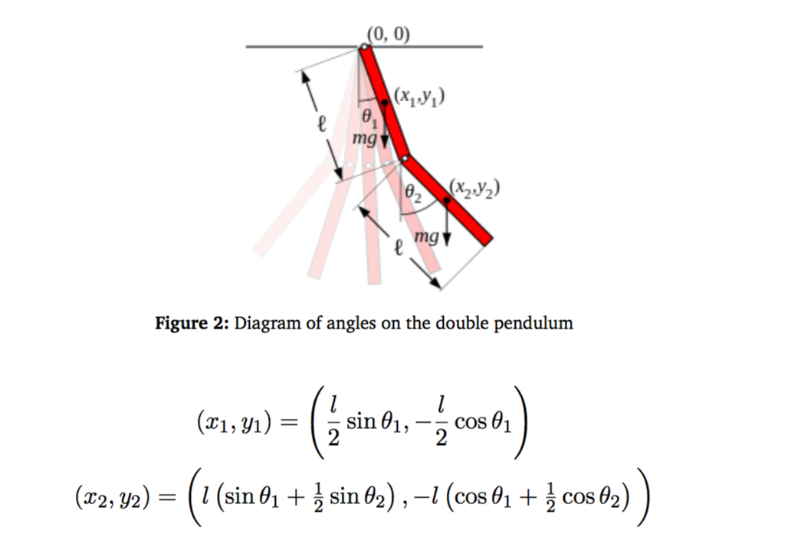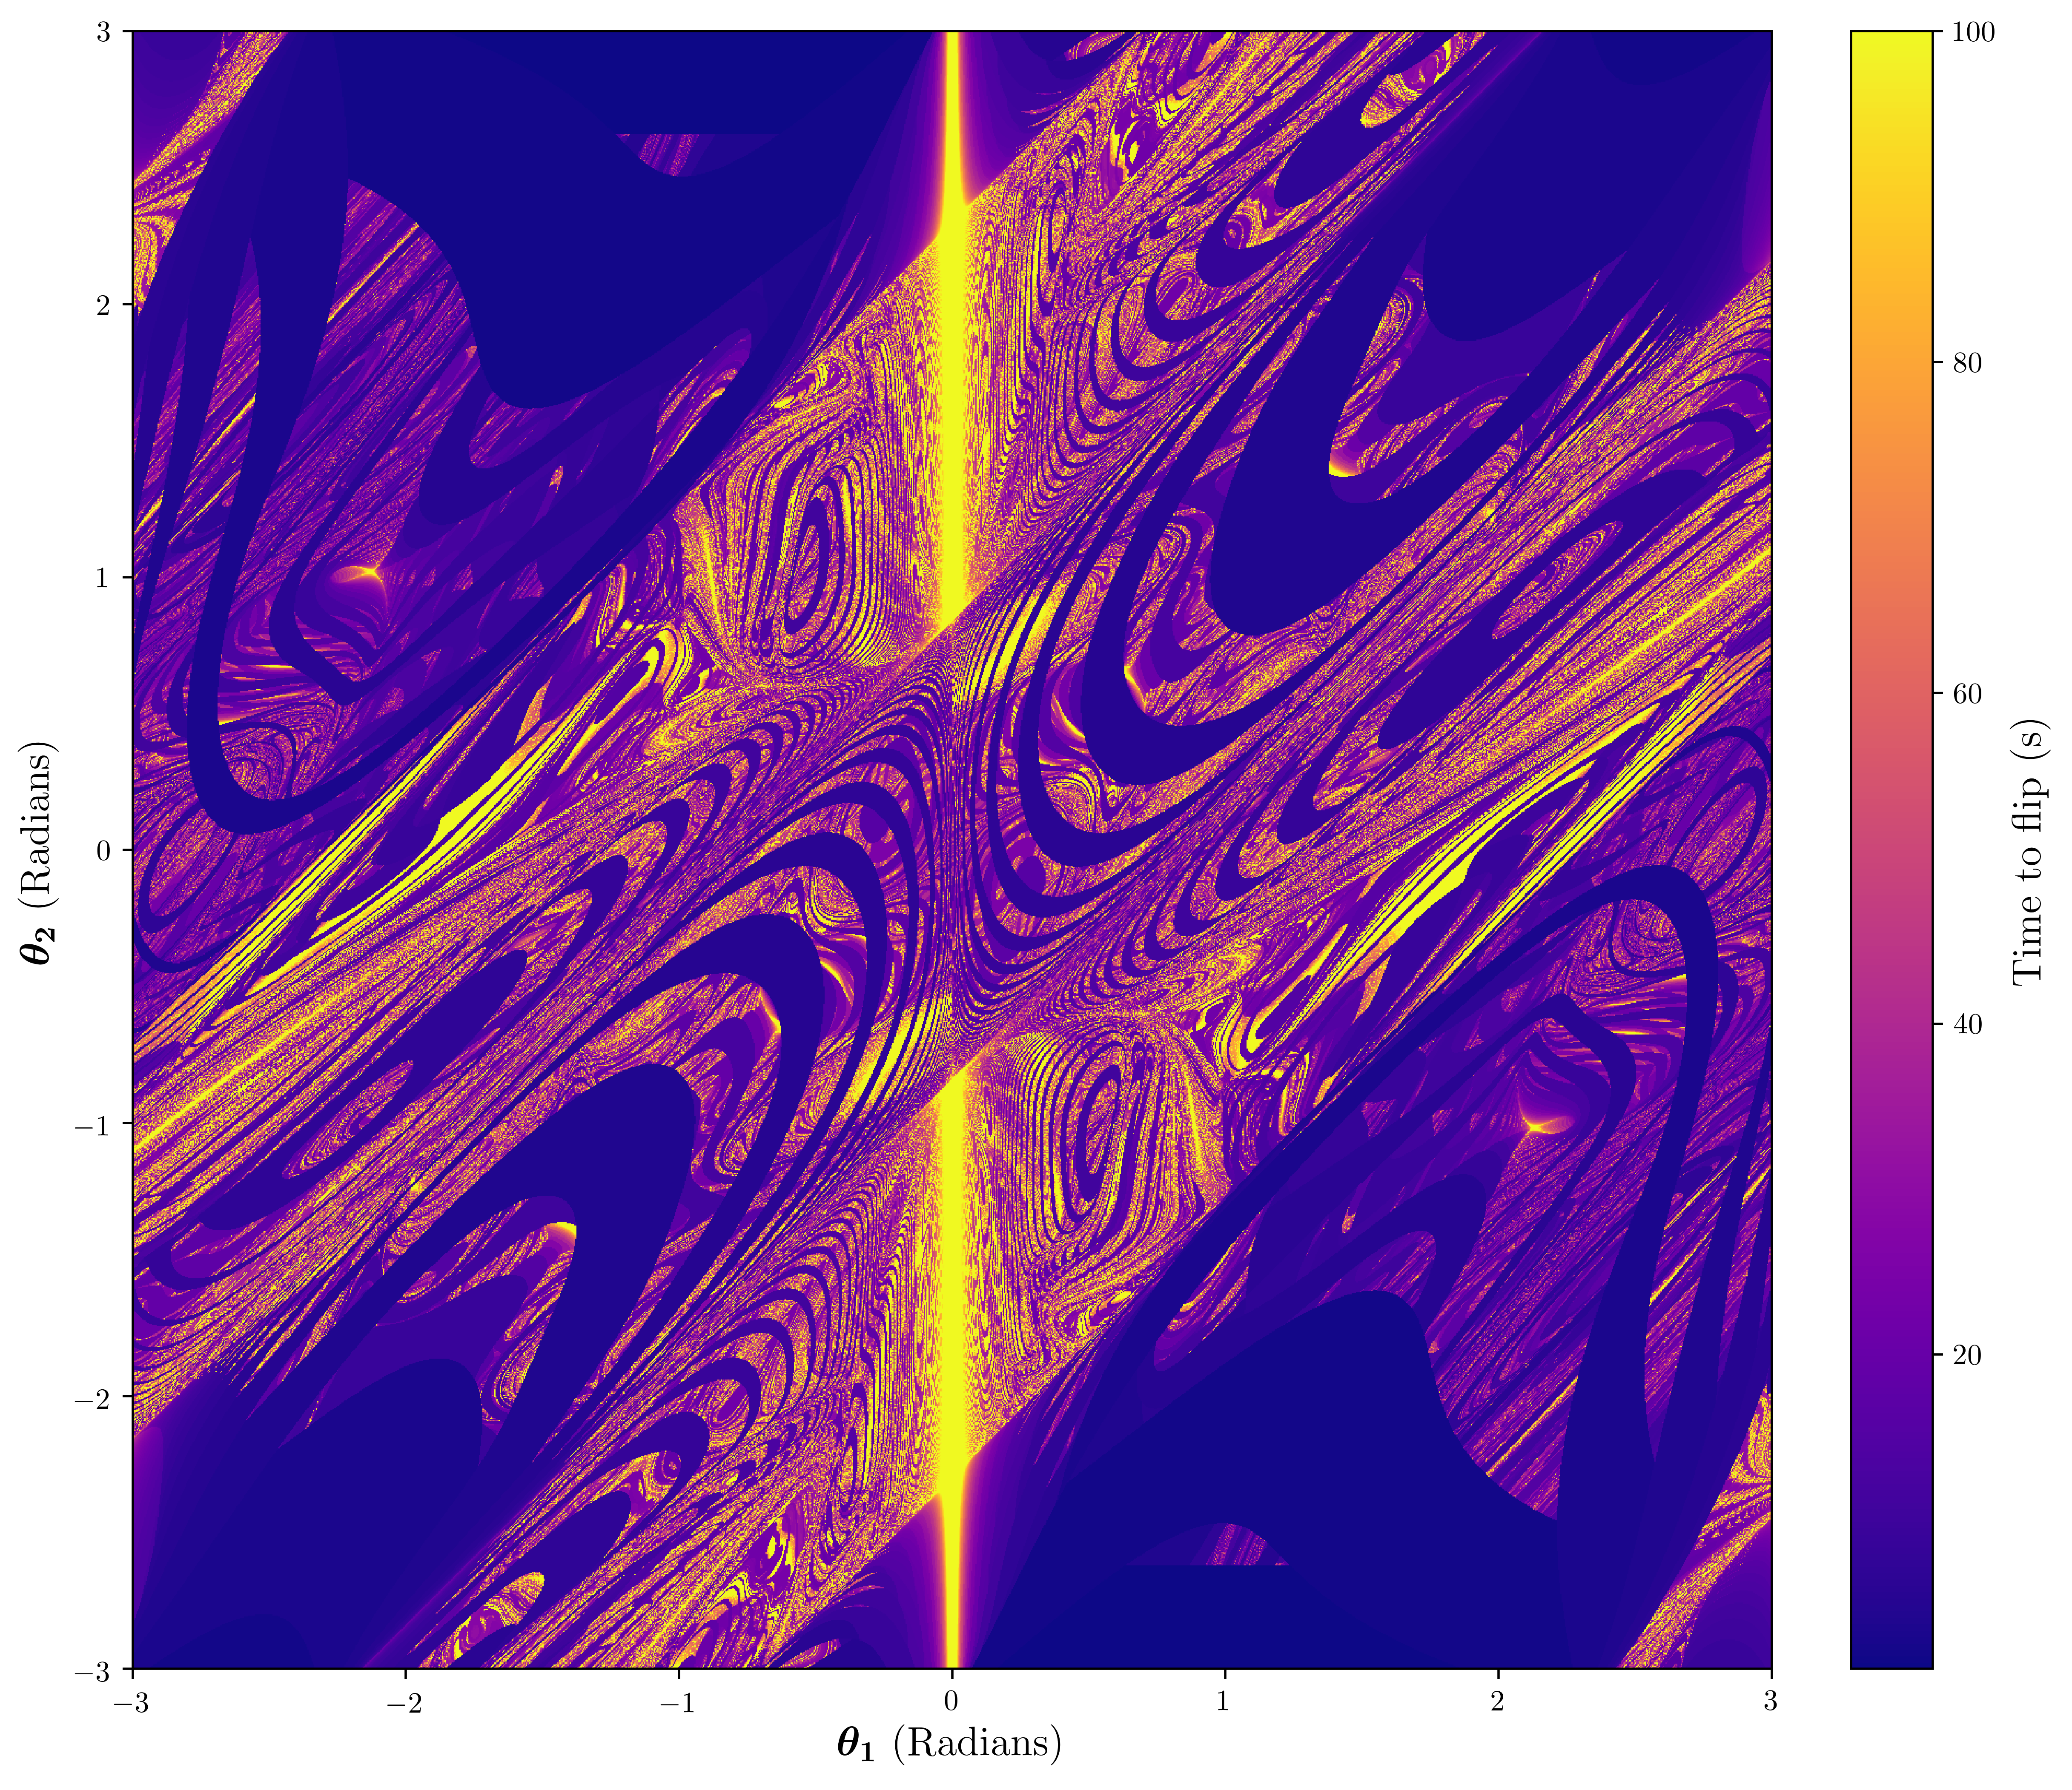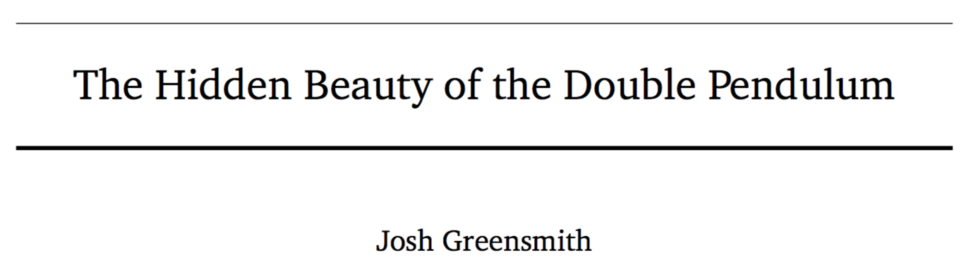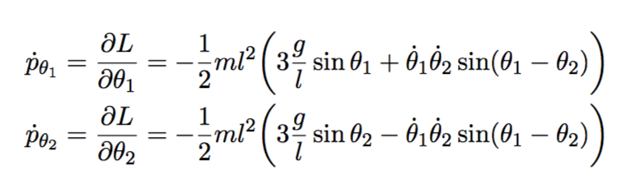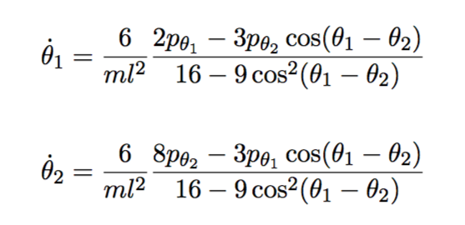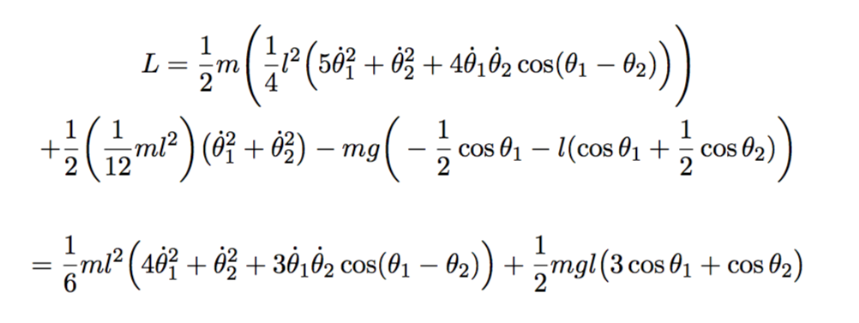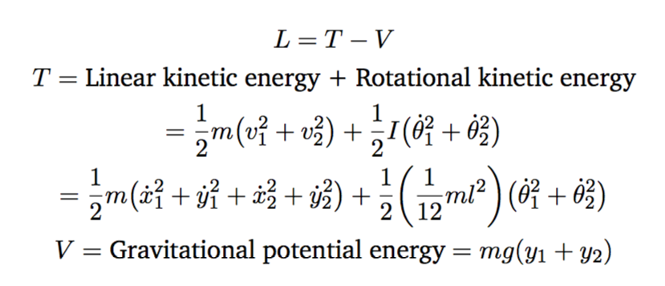

X and y coordinates of each pendulum based on their angle and lengths

Josh Greensmith

The Euler-Lagrange equation used to find the characteristic equations from the Lagrangian by taking partial derivatives with respect to the core variables.

Defining and simplifying the Lagrangian

Characteristic Equations